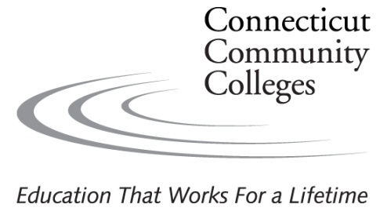

I give my permission to Connecticut Community Colleges, which includes Naugatuck Valley Community College, to use, without compensation of any kind, my name and/or photographs of me or my child for publicity, promotional, or advertising purposes in all forms and media (for example, newspapers, TV, brochures, posters, website and other forms of traditional and social media) and in all manners, including composite representations, for trade, educational, or any other lawful purposes of the System of Connecticut Community College’s choice. The permission I grant herein includes my consent under the Family Educational Rights and Privacy Act (FERPA) to disclose as part of my education record my name and photographic image for the purposes and in the manner stated herein. I hereby release and discharge the Colleges of the System of Connecticut Community Colleges and their agents, officers and employees from any claims, suits, or liability whatsoever for invasion of privacy, distortion or alteration of photographs, libel, slander or otherwise in such use. I waive any right to inspect or approve the finished product, including written copy that may be created in connection therewith. I have read this release and am fully familiar with its contents. (If under age 18, parent or guardian must also sign.)

Signature:_________________________________________ Date: _______________________

Print Name:____________________________________________________________________

Address:______________________________________________________________________

City______________________________________ State:____________ Zip:_____________

Telephone:___________________________________

Email:_______________________________________

Revised 10/3/17

