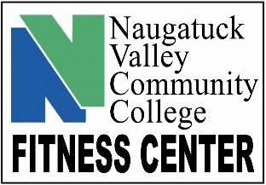
HOURS
MONDAY/WEDNESDAY: 10 – 6
TUESDAY/THURSDAY: 7:30 - 6
TO BECOME A MEMBER:
- Show Student ID
- Sign up the first day you want to work out.
- Know your banner ID and fill out paperwork.
FITNESS CENTER ETIQUETTE:
- Put everything back where it belongs. Don’t leave a trail of equipment.
- Don’t hog the equipment when the center is busy. Use it, don’t sit on it.
- Wipe things down after you use them. Wipe your sweat off everything you touch.
- Respect personal space. Don’t try and squeeze into area if someone else is working out.
- Be flexible if the center is crowded. Not every machine is available when you want it.
- Don’t be afraid to ask for space. If you feel someone is crowding you, just let them know you may need a bit more space to complete your workout
- Be mindful of your surroundings. Look around before you start swinging a kettlebell or doing jumping jacks, etc. People are constantly moving so take note.
- Ask for help if you don’t know how to use a specific piece of equipment or if you are looking to work on a specific muscle group.
- Plan a routine ahead of coming into the center. It works better when you have a plan of attack and know what equipment you want to use to complete a workout.
SAFETY:
- Proper attire must be worn at all times to prevent injury. Comfortable athletic clothing like sweats, shorts and t-shirts plus good, clean sneakers. No jeans, crocs, work boots or everyday clothes.
- No hanging out. Come, workout and leave.
- No food. Water and sports drinks only.
- No bags or backpacks allowed on main floor. Use the lockers.
- Don’t do anything above your limits or what you are not familiar with. ASK FOR HELP
KNOWING YOUR LIMITS:
- Ask the staff for help and/or assistance when using the equipment. Never lift more weight than you are capable of. If you can’t lift a weight for 10 consistent repetitions, it is TOO HEAVY for you. Choose a lighter weight.
- If any part of your body starts to hurt while performing an exercise STOP.

